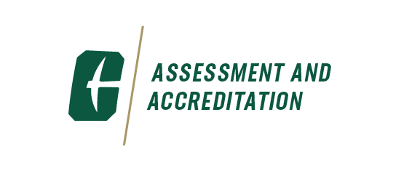

AAAT Meeting

October 15, 2024 | 10:00 – 11:30 AM

Fretwell 310

**The Academic Affairs Assessment Team (AAAT)** was formally established in 2006. The purpose of the team is to bring together assessment professionals from the eight colleges, Undergraduate Education, Atkins Library, and Student Affairs to discuss assessment issues, share assessment data and best practices, and collaboratively brainstorm solutions to assessment problems.

|  |  |
| --- | --- |
| **Agenda Items** | **Facilitators** |
| **Welcome & Introductions** | Christine |
| **University updates**  Foundations of American Democracy course | Mitch Cottenoir |
| **Presentation**  Topic: *An Analysis of DFW Rates and Factors Affecting Students' Odds of Getting DFWs at UNC Charlotte* | Martha Bottia |