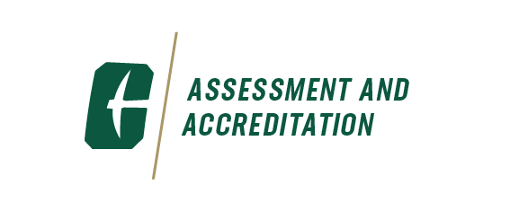

AAAT Meeting

March 25, 2025 | 1:00 – 2:30 PM

Fretwell 310

**The Academic Affairs Assessment Team (AAAT)** was formally established in 2006. The purpose of the team is to bring together assessment professionals from the eight colleges, Undergraduate Education, Atkins Library, and Student Affairs to discuss assessment issues, share assessment data and best practices, and collaboratively brainstorm solutions to assessment problems.

|  |  |
| --- | --- |
| **Agenda Items** | **Facilitators** |
| **Welcome** | Christine |
| **Presentation**  Topic: *GenEd Outcomes Assessment Results* | Mitch &  Heather |
| **Academic Program Planning and Evaluation**  Academic Program Planning Guide | Mitch |
| **Program Review Process**  Questions | Christine |
| **Announcements**   * Faculty Showcase – April 2nd @ 10:30 am – Halton Reading Room * Excellence In Planning and Assessment Recognition Ceremony – April 23rd @12 – 2 pm – Halton Reading Room * New CAD in CHESS – Courtney Hill – starts April 1st | Christine |
| **Other**  Questions |  |